**The Daggers:**

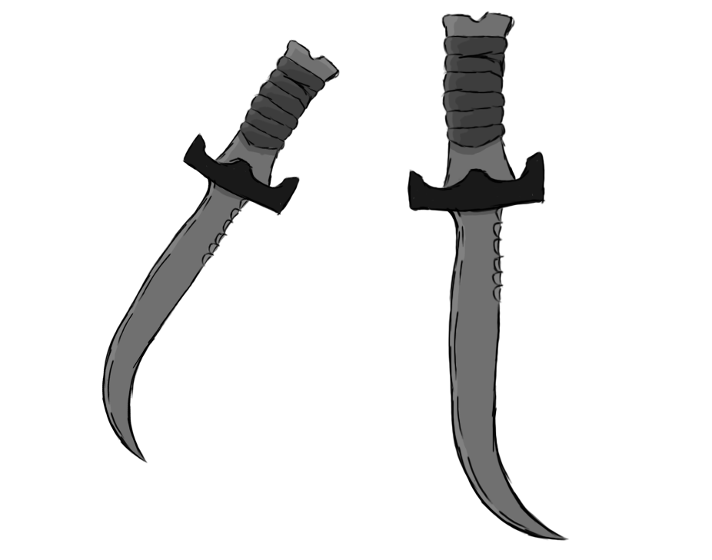

Figure - Weapon: Daggers

**Brief Synopsis**

The daggers a weapon with exceptionally high damage output, there use is mainly for 1 vs 1 fights. This is due to them having the smallest attack range out of all weapons, requiring the player to be basically either on-top or extremely close to the enemies they are fighting. The reason for this is to allow players aiming for faster speeds a quicker way of disposing of enemies, while also increasing the risk of the player taking damage due to there close proximity to the things they are fighting.

**Special Ability**

**Wall Running:  
 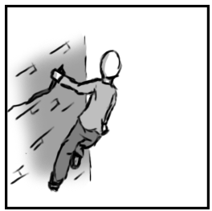**

Figure - Animation Storyboard: Wall Running

**Special:** The player jumps and locks their movement onto the wall, running forward keeps them attached allowing them to travel vertical distances fast across flat giving them access to potential skips and shortcuts.

**Combat Ability’s**

**Hack ‘n’ Slash:**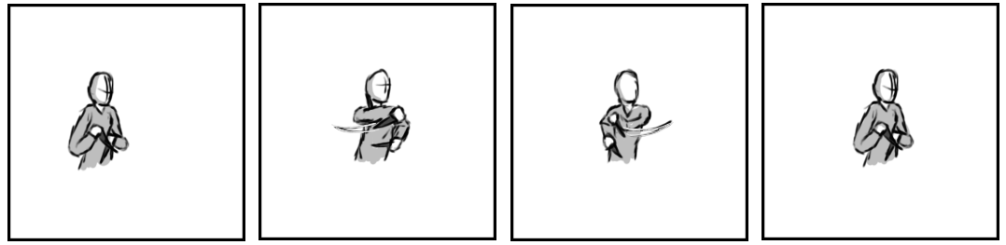

Figure - Animation Storyboard: Hack ‘n’ Slash

**While grounded and stationary:** The player brings their daggers across and away from there chest. If this attack is repeated it will enter into a combo where the daggers will land continuous strikes, finally ending by returning to their resting position.

**Lunge:**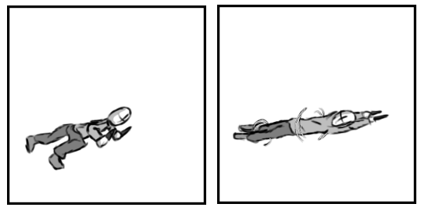

Figure - Animation Storyboard: Lunge

**While grounded and in motion**: The player propels themselves forward while spinning. During this the player will have a brief invulnerability to attacks while dealing damage to anything the player comes into contact with.

**Killer Top:**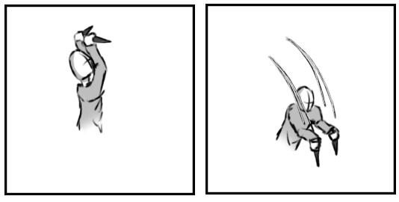

Figure - Animation Storyboard: Killer Top

**While aerial:** The player raises both daggers into the air and comes crashing down with them drawn. Any enemy directly underneath the player will take a massive hit to their health.